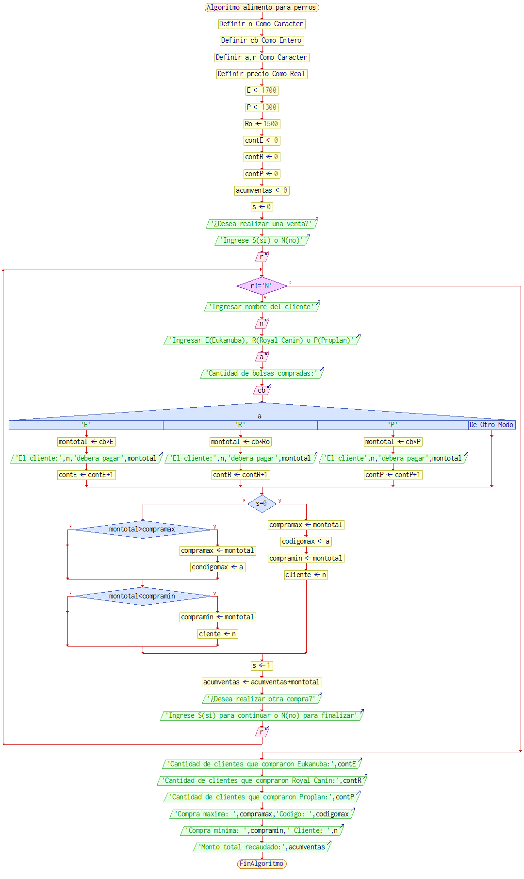**Tarea Obligatoria – Primera Valoración**

|  |  |  |  |  |  |  |  |  |  |  |  |  |  |  |  |  |
| --- | --- | --- | --- | --- | --- | --- | --- | --- | --- | --- | --- | --- | --- | --- | --- | --- |
| **r** | **n** | **cb** | **a** | **E** | **P** | **Ro** | **montotal** | **contE** | **contR** | **contP** | **s** | **compramax** | **codigomax** | **compramin** | **cliente** | **acumventas** |
|  |  |  |  | **1700** | **1300** | **1500** |  | **0** | **0** | **0** | **0** |  |  |  |  | **0** |
| **S** | **Juan** | **3** | **R** |  |  |  | **4500** |  | **1** |  |  | **4500** | **R** | **4500** | **Juan** | **4500** |
| **S** | **Pedro** | **2** | **E** |  |  |  | **3400** | **1** |  |  | **1** |  |  | **3400** | **Pedro** | **7900** |
| **S** | **Ana** | **4** | **R** |  |  |  | **6000** |  | **2** |  |  | **6000** | **R** |  |  | **13900** |
| **S** | **Martina** | **3** | **P** |  |  |  | **3900** |  |  | **1** |  |  |  |  |  | **17800** |
| **S** | **Martin** | **5** | **E** |  |  |  | **8500** | **2** |  |  |  | **8500** | **E** |  |  | **26300** |
| **N** |  |  |  |  |  |  |  |  |  |  |  |  |  |  |  |  |

**Cantidad de clientes que compraron Eukanuba: 2**

**Cantidad de clientes que compraron Royal Canin: 2**

**Cantidad de clientes que compraron Proplan: 1**

**Compra máxima: 8500 Código: E**

**Compra mínima: 3400 Cliente: Pedro**

**Monto total recaudado: 26300**